Kura Labs Cohort 3 – Deployment 1

Name: Walter Emmanuel

Date: 28/08/2022

**Documentation of Deployment**

**Installing Jenkins on an EC2:**

So, I started this deployment by creating an Ubuntu EC2 on Amazon Web Services with port 22, 80 and 8080 open.

Afterwards I access my EC2 using the key pair which was provided to me and use the ssh command to log into the EC2.

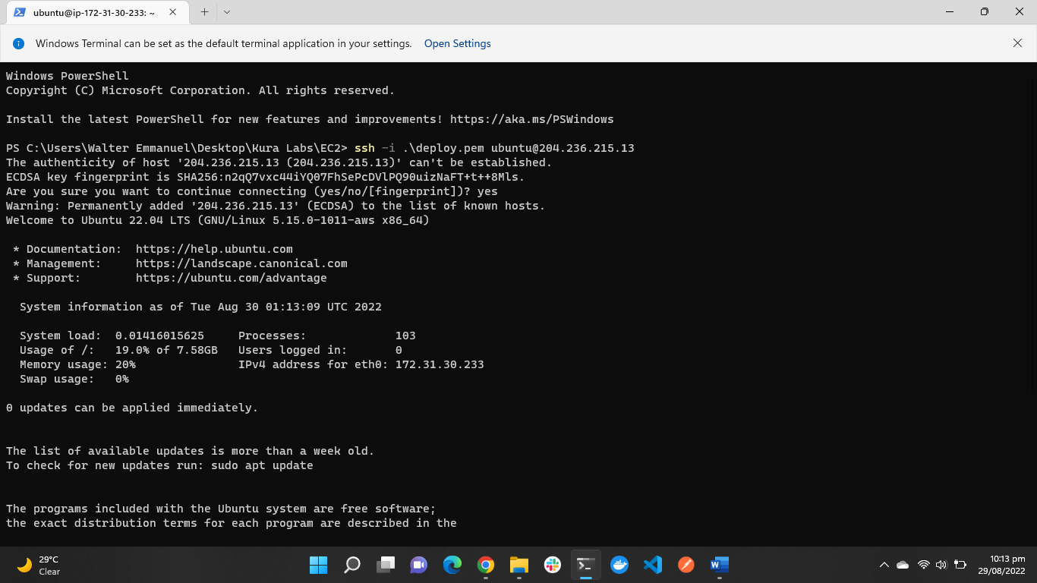

After logging into my EC2, I installed the Default-jre package and also Jenkins using the sudo apt install command.

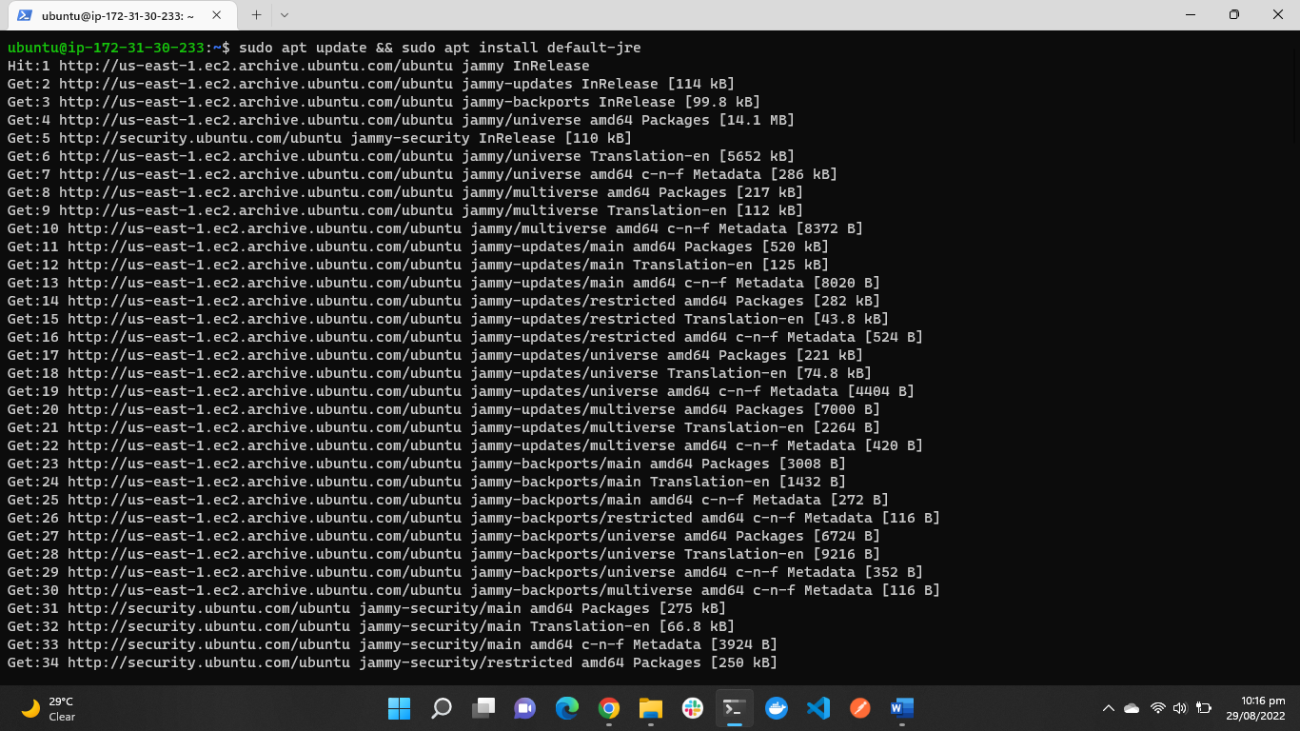

The “wget -q -O - https://pkg.jenkins.io/debian-stable/jenkins.io.key |sudo gpg --dearmor -o /usr/share/keyrings/jenkins.gpg

File '/usr/share/keyrings/jenkins.gpg'” is used to download the signing key for Jenkins.

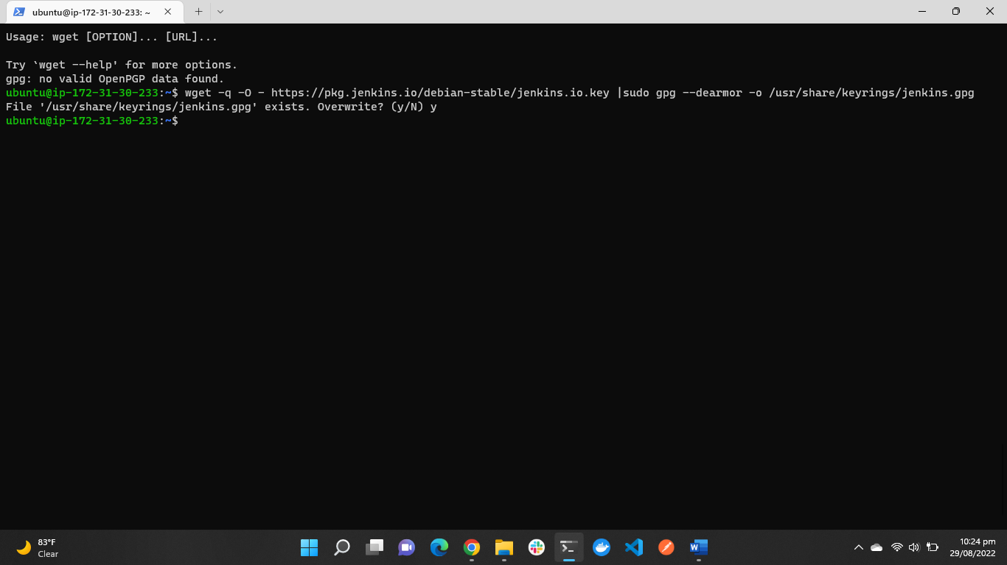

Once installed I accessed my Jenkins server through my browser.

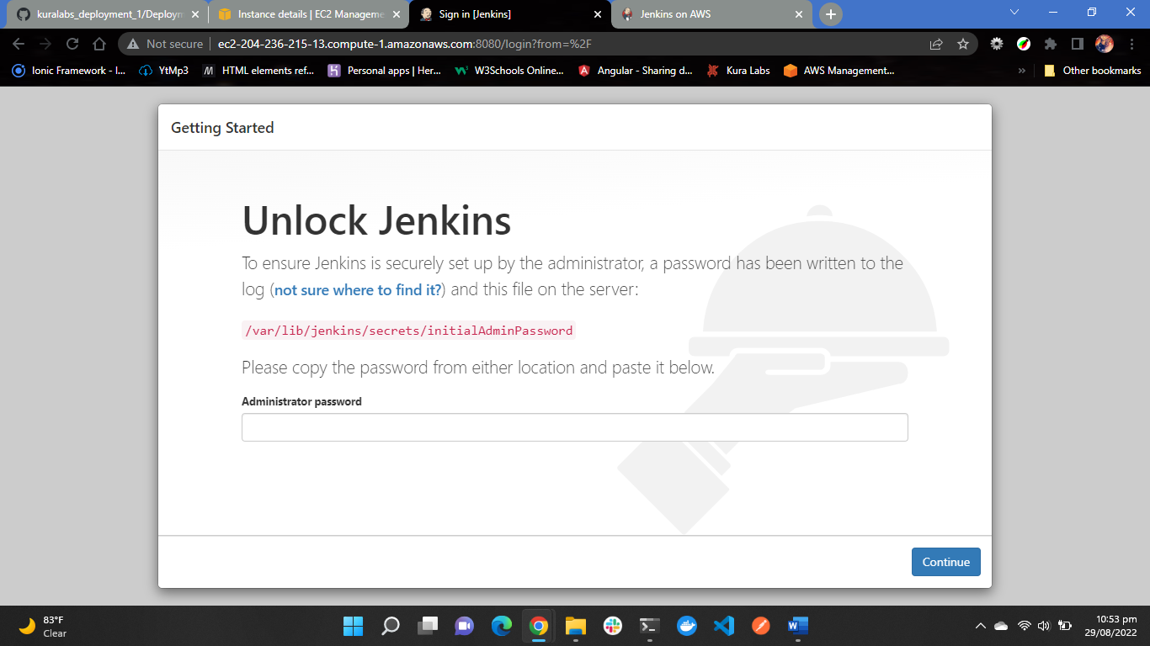

After getting through that I went on to set up my page created an admin. Once that was done it sent me to the home page

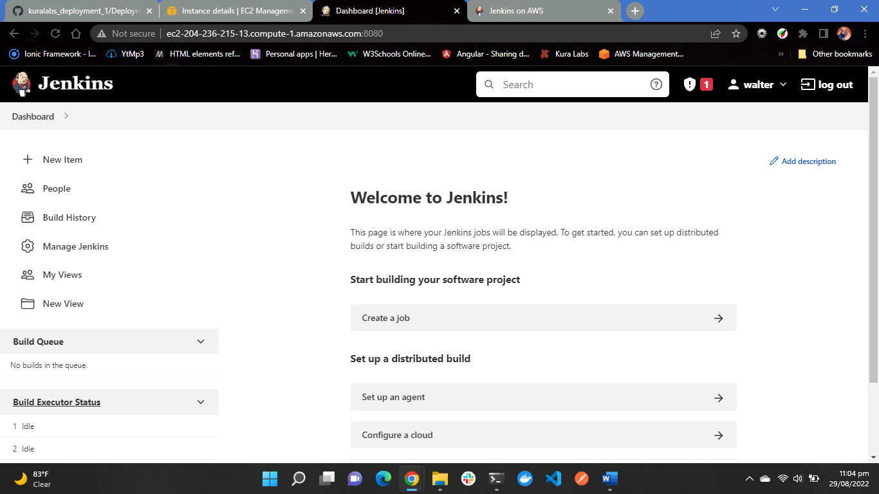

Once I reached this page, I went to the manage Jenkins tab to install the Amazon EC2 Plugin.

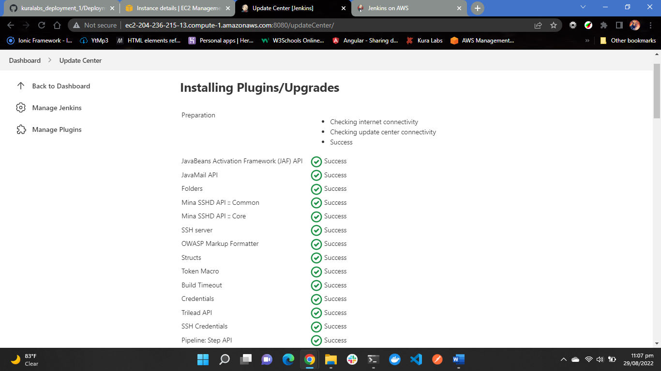

Afterwards I had to add my EC2 to jekins

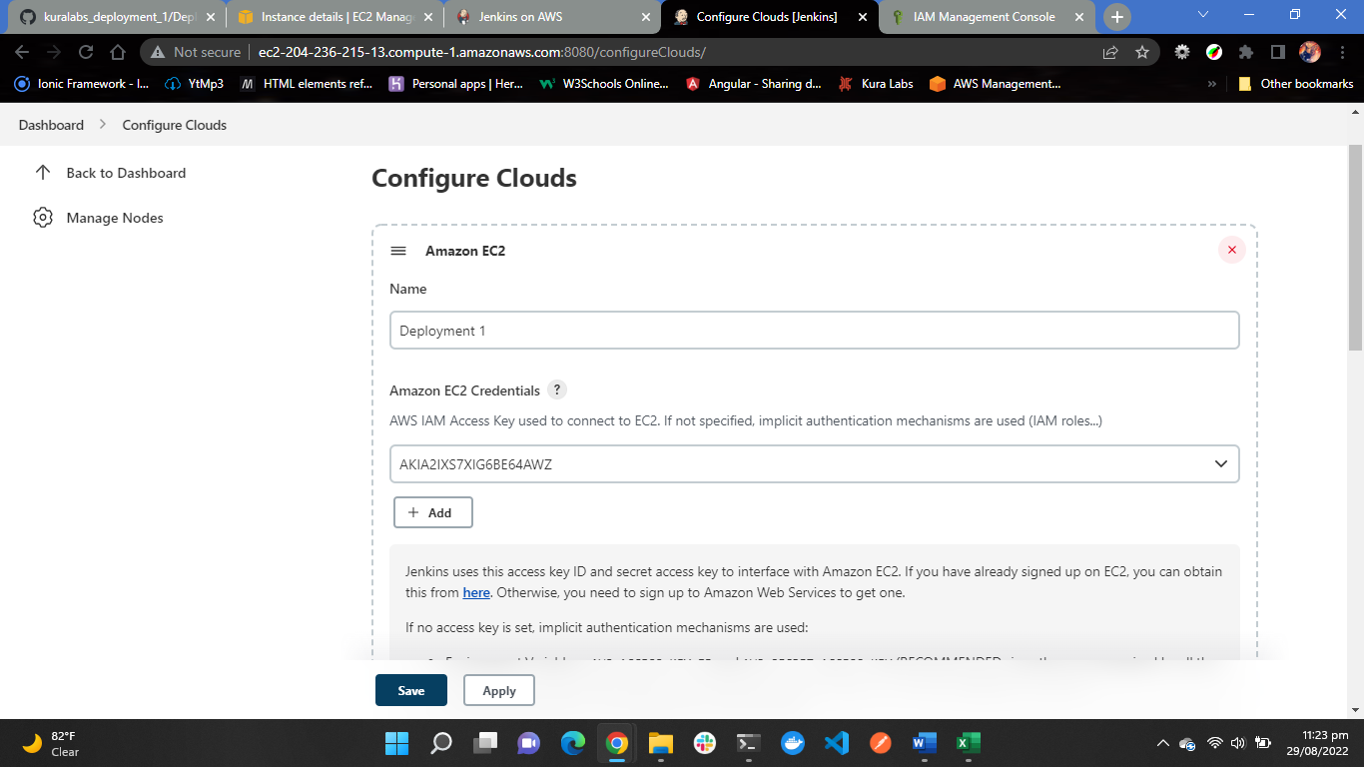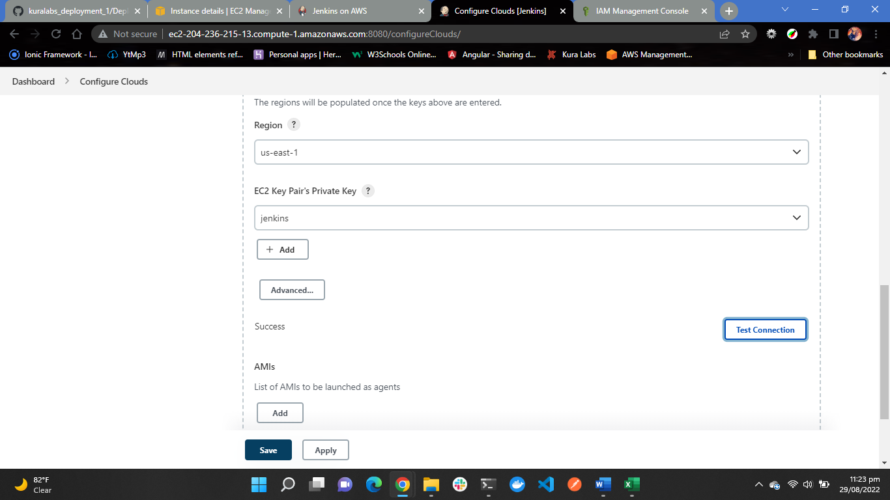

**Installing a Virtual Environment:**

Once I set up Jenkins on my EC2, I went onto installing virtual environment for the python application to run

I ran into some problems when trying to install python3-10-venv

But I fixed this issue using the following command

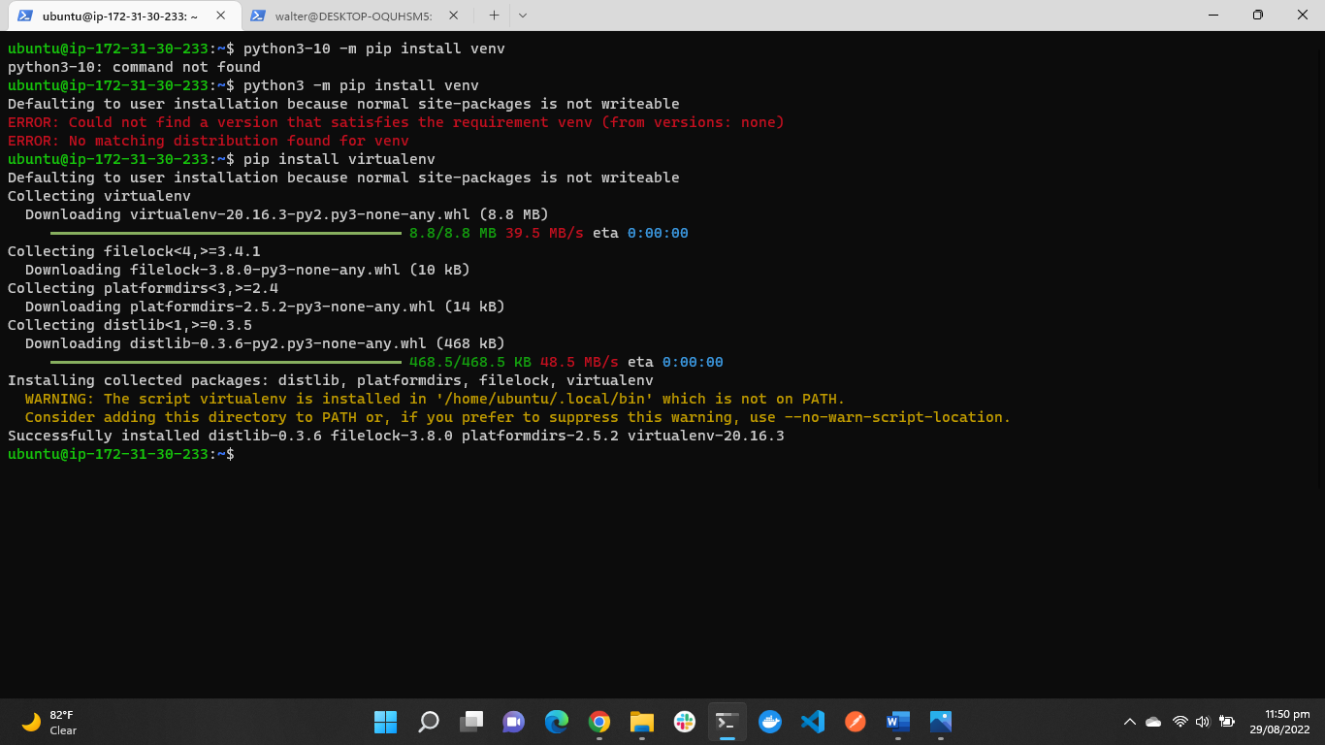

Once that was completed, I then went and created a personal token on GitHub.

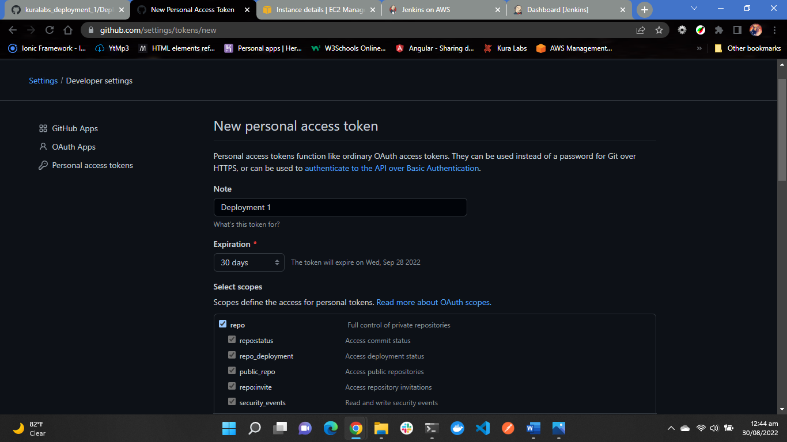

**Creating a multibranch build**:

Now I logged back into Jenkins and created a new item which was the multibranch build.

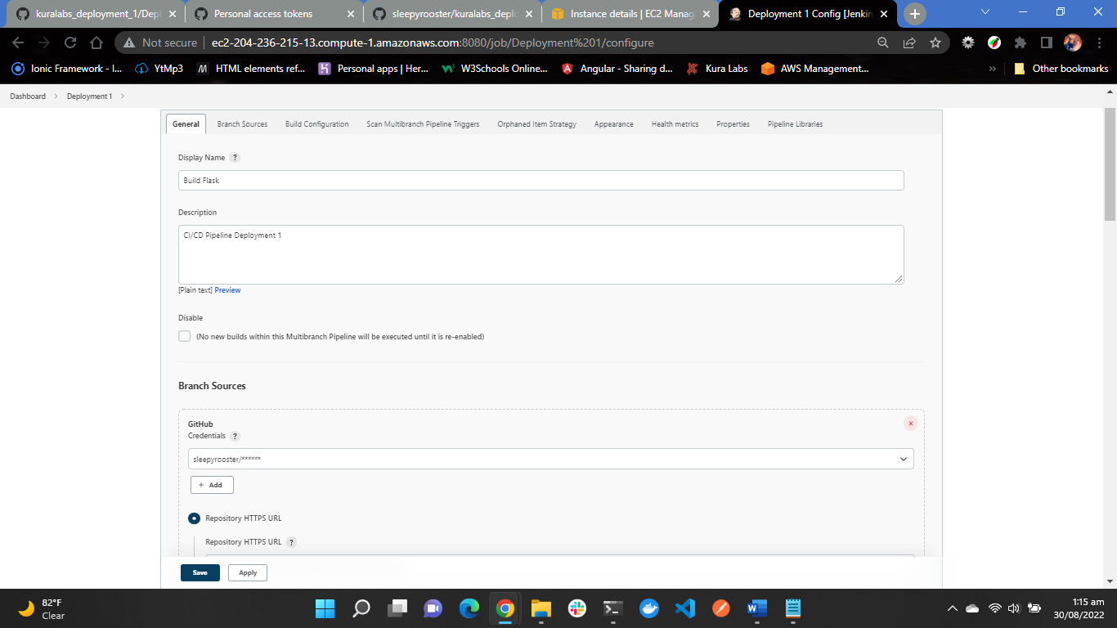

Once I entered my personal token and the path to my GitHub Repository, I saved and applied the setting, but my build failed for the first time.

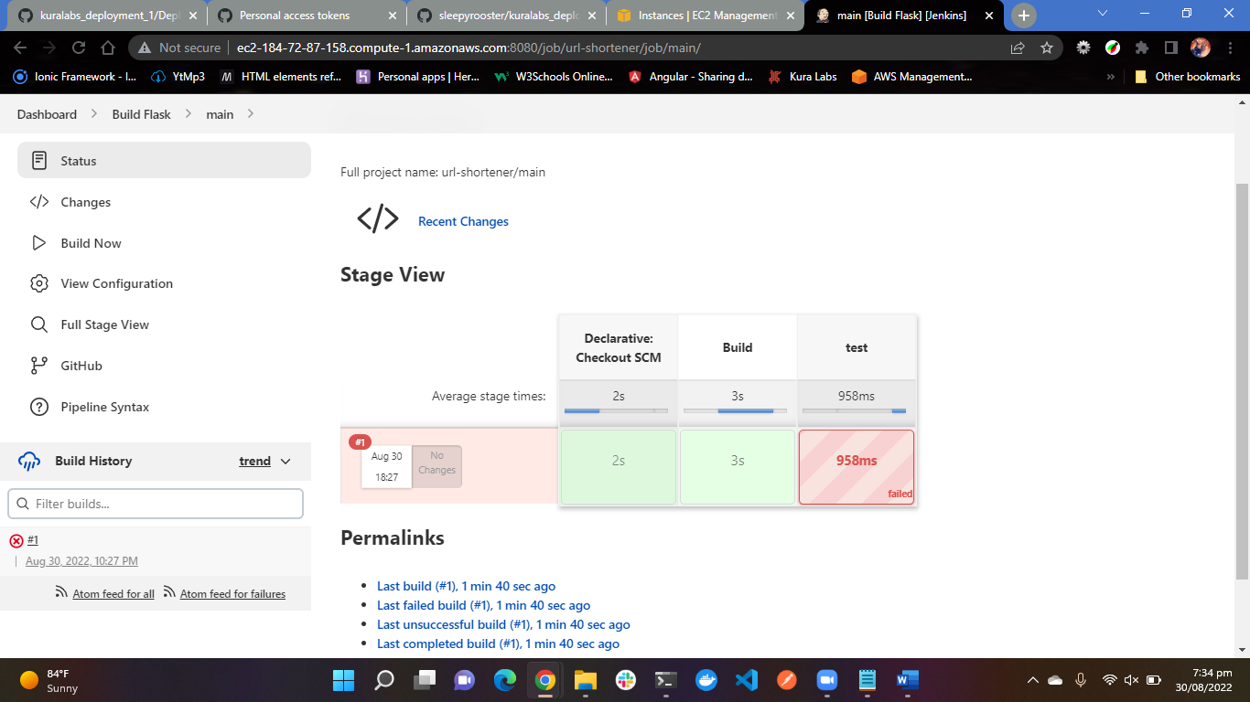

I investigated the log file for the first build, and I saw that python3.10 venv wasn’t install so I had to install it again

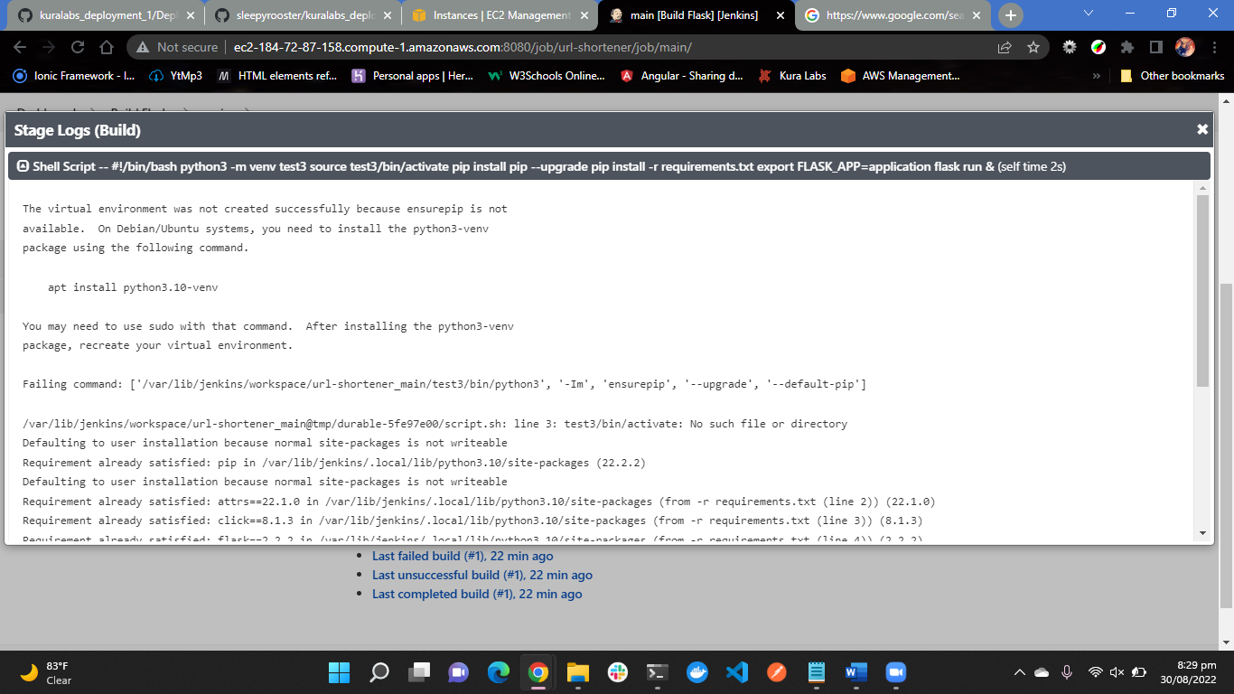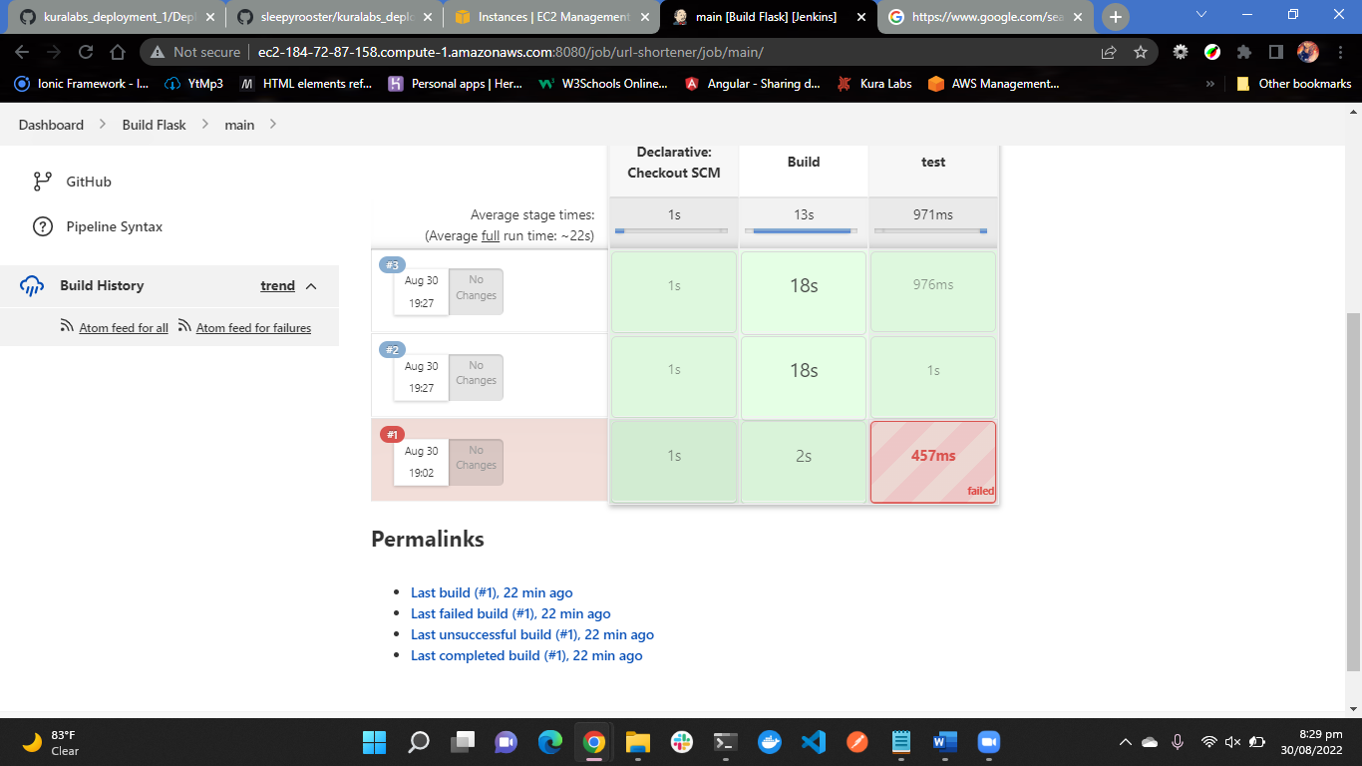

**Downloading the files from GitHub and Deploying it to Elastic Beanstalk**

I first cloned my repository to my local machine and then I zipped the file.anstalk, but I ran into a problem after the process was completed

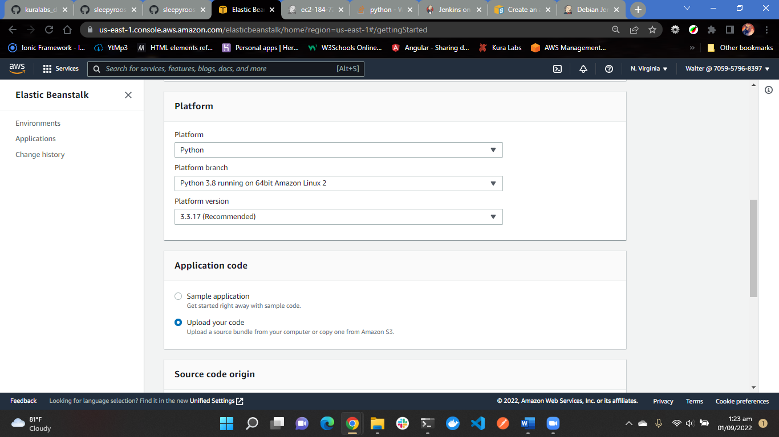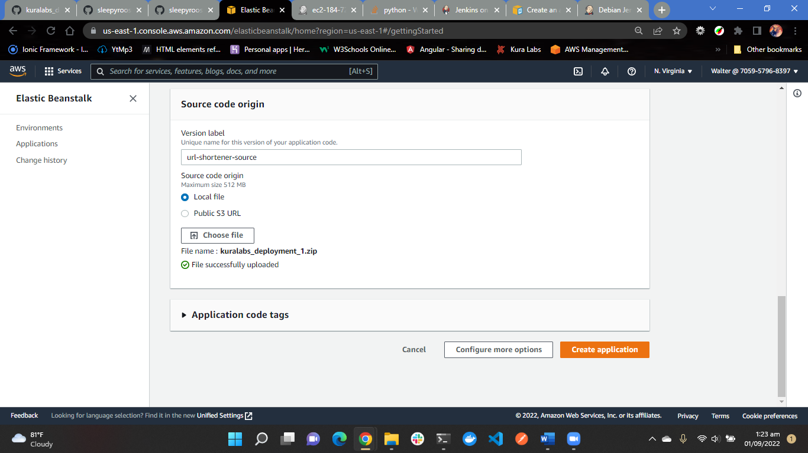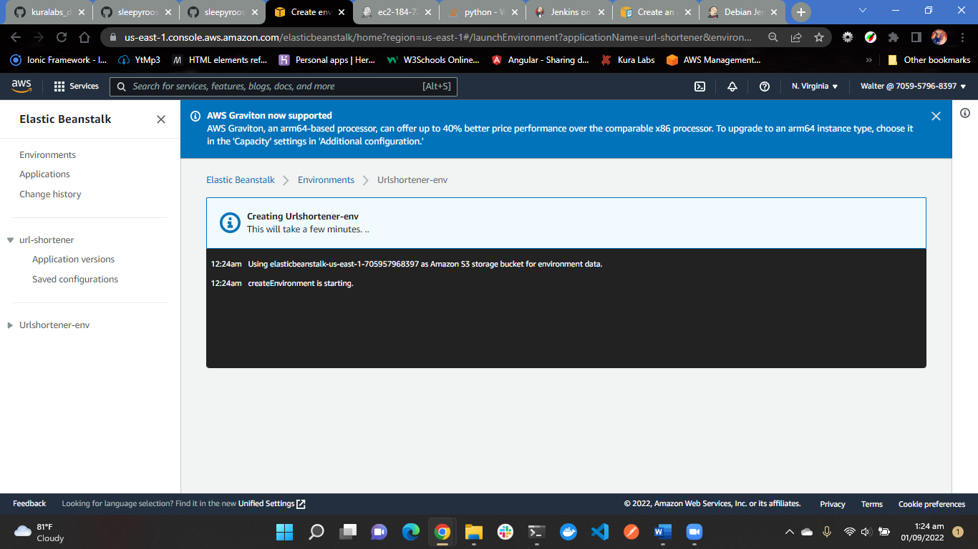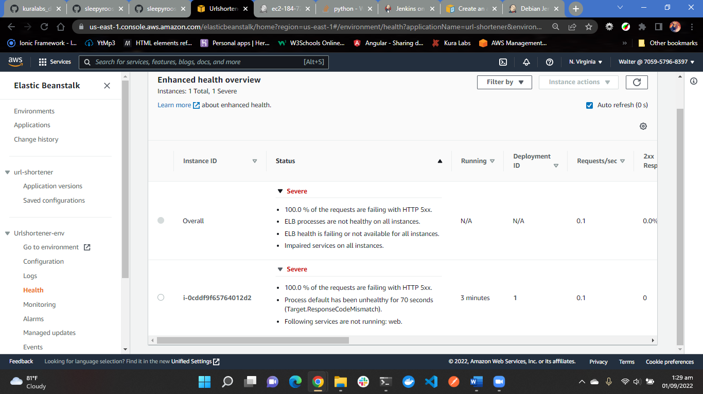

It seems that my zip file was corrupted, so I zipped the clone directory again and I build

